**User manual for Finiflux2.0 (Finite element method for quantifying groundwater fluxes to streams using Radon)**

By Ben Gilfedder and Sven Frei

*Limnological Research Station & Department of Hydrology, University of Bayreuth, Universitätsstrasse 30, 95447 Bayreuth, Germany*

Ok here is a major update to the FINIFLUX model. We have:

1. Simplified the file system considerably to one! Excel table that is read into the model.
2. Included various residence time distributions in the hyporheic zone. These include a gamma model, power law and the classic exponential model
3. In the numerical scheme we have included ‘upstream weighting’ which reduced numerical dispersion.
4. Uses BeoPEST instead of PPEST so that you can run your models easily over a network or internet connection. It also simplifies the procedure.
5. The ability to include tributaries into the model
6. An accessory graphing program so that you can follow BeoPest progress in optimisation

This document is the new manual to FINIFLUX2.0. Please also see the paper for a description of the original FINIFLUX, which you should cite if publishing model results (please…!):

Technical Note: FINIFLUX an implicit Finite Element model for quantification of groundwater fluxes and hyporheic exchange in streams and rivers using Radon, in Water Resources Research 2015.

**Introduction**

This model is intended to make calculated groundwater fluxes estimated using Rn more mathematically robust and also provide information on how important the different variables in the model are for determining the measured Rn activities. It is based on an implicit solution to the governing mass-balance differential equations using a finite element code. This model is fitted to measured data using the parameter optimisation model BeoPEST (Doherty, 2010), which systematically varies variables such as the groundwater flux and hyporheic exchange residence times to reduce the residual mean square between measured and modelled data. Below are the basic steps to run the model in streams and rivers. For the background mathematics and case studies please see the associated paper and example datasets. The description below is to set up a model including hyporheic exchange. All the following steps are **based on the files found in the downloaded folded** **exec**.

A note about folder directory paths. We have had comments from our students using FINIFLUX that they have problems running the model when there are spaces within the folder or path names. FINIFLUX is run from a ‘DOS BOX’ and thus some of the restrictions of DOS apply. Please do not have any spaces within the directory path. Very long directory path names (or the German ‘Umlaute’) should be avoided.

**Instructions**

1. There is now only one excel file that all your data need to be entered into. This is called FINIFLUX.xlsx. What used be 15 separate files is all now all in this spreadsheet making the model much easier to use and gives a better overview of where data may be missing. It’s pretty self-explanatory now, but we go through cell by cell below to explain what should be entered in case of uncertainty.

A note on data structure: There are still the important differences in the data structure. On one hand, we have **‘Nodes’** or **measured data points (columns F and G)**, while on the other hand we have ‘**Elements’** or **reaches (columns I-T)**, which is the lengths of stream between measured points. By definition, the number of Elements is one less than the number of Nodes, since there is always a measurement point at one of the boundaries (up-stream or downstream boundary).

1. The program that generates the BeoPEST and FINIFLUX input files and slaves is called ‘pre_pest.exe’. It reads in the new FINIFLUX.xlsx spreadsheet and extracts the data that it needs to run, including setting up the directory structure and BeoPEST files. We have mostly used default settings for the BeoPEST input file, but the interested user is direct to the very comprehensive PEST/BeoPEST manual for more information on these settings, as well as more generally how PEST works. Moreover, the BeoPEST input files can still be changed after the initial set-up, but before the model run, by a more experienced user (e.g. parameters in the Singular Value Decomposition (SVD) routine can be edited). The main file that drives PEST is the **finiflux.pst** file.
2. Ok so let’s look at the new excel spreadsheet. Note that the sheet is already populated with an example data set to give an idea how your data should look when everything is entered correctly. You can simply over-write our data by copy-and-paste of your data.
   1. **Cell B4**: path_definition this shows the program where you have your input files, where slaves will be created and where you want to run your model. It is easiest to copy it from window header e.g. D:\Programs\finiflux
   2. **Cell B6**: Number of CPUs this is the number of slaves that you want to run. Number of slaves = number given minus one, since one of the CPUs is also the Master. We have found that 3 slaves work well on quad core machines and also allows you to work on other things while the model is running. In this case we recommend entering ‘4’ in this file. We have used up to 16 CPUs on our ‘big machine’ and even more when using multiple machines over an internet connection.
   3. **Cell B8**: Degassing Model. This allows you to choose between two empirical equations (enter ‘1’ or ‘2’) for river-atmosphere exchange (degassing) or entering your own degassing data (enter ‘3’).
   4. **Cell B13**: hz_on_off: Allows you to run the model with or without the hyporheic zone module. 1 is on 0 is off.
   5. **Cell B17:** Distribution for HZ Residence Times: Allows you to choose between different types of residence time distributions within the hyporheic zone if you have activated the hyporheic zone module. You can choose between exponential, power law and gamma.
   6. **Cell 22:** ALPHA Parameter for GAMMA model: this needs to be defined for the gamma residence time distribution. There is little data about what should be used here. It determines the shape of the RTD, have a play with this. Above a value of 2 gives a more ‘advection-dispersion’ type curve, while below 1 has a long tail.
   7. **Cell B24:** Upstream Weight: Determines the upstream weighting. This is part of the numerical process and corrects numerical dispersion when on. We have found that a value of 0.5 works well in many streams by increasing the fit between measured and modelled data. If in doubt, you can turn it off by entering a ‘0’.
   8. **Cell F2:** Observation Points. This is where the **‘node’** data starts to be entered. Observation Points is the distance from the most upstream measurement point in meters.
   9. **Cell G2:** Measured Rn Concentrations: as the name implies, this is your measured radon activities in Bq m-3.
   10. **Cell I2:** Reach number. Here the ‘**elements’** start. Reach number is the number of reaches starting at the most upstream location. This will be the number of sampling points minus one.
   11. **Cell J2:** Reach Length. As the name implies this is the length in each reach in meters.
   12. **Cells K and L:** These are the average reach length and width in m. These should be measured in the field or by measurements on maps or by GIS.
   13. **Cell M2:** GW endmember**.** This is the radon activity in the groundwater system that is representative for each reach. Each reach needs a value.
   14. **Cell N2:** Depth of Hyporheic Zone. This is the approximate depth of the hyporheic zone in meters. This will be optimised by PEST but needs an initial value for each reach. We have given a default of 0.5 m which should be an adequate starting value for many streams.
   15. **Cell O2**: Porosity of Hyporheic Zone. This is the porosity of the hyporheic zone for each reach (default = 0.4). It is not optimised by BeoPEST.
   16. **Cell P2**: Surface Inflow: This is the discharge from tributaries into the main river.
   17. **Cell Q2:** Inflow Length: This is the width of the tributary as it enters the main river stem.
   18. **Cell R2:** Concentration of Surface Inflow: this is the radon activity in the tributary.

We need to make a short note on tributaries, since this is the only thing that is slightly complicated with the new FINIFLUX version. We have also included an example dataset from the Selke River to illustrate how tributaries are included. The important thing with tributaries is that in addition to the data entered into cells P2-R2, you need to also create elements and nodes for where the tributary comes into the main river. This additional ‘reach’ is usually only a few meters wide depending on the width of the tributary, but it is important for the calculation. You need Rn concentrations above and below the confluence as well as the other standard reach data. Concentrations below the confluence can be either measured (best) or calculated using a mixing model between the main river above the confluence and concentrations in the tributary.

* 1. **Cell S2:** River Discharge. This is the river discharge of the main stem.
  2. **Cell T2:** User Defined Degassing Values (only for option: Degassing Model = 3). This is the degassing value if you have determined it yourself. Units are m/s. If you have units s-1 as in many empirical degassing equations you need to multiply by the average reach depth. We have found that particularly in alpine rivers you need to measure the degassing because of all the crazy turbulence there that is poorly captured by our degassing models.

1. Ok once you have filled in the spreadsheet it is time to run the BeoPEST set-up program ‘Pre_pest.exe’. Hold ‘shift’ and right-click on the folder containing your files and the downloaded programs. Select ‘Open Command Window Here’ from the menu that appears, which will open a dos box. Note, that some of the newest versions of windows don’t have this function any more (this is really frustrating!!). So now if you don’t have ‘Open Command Window Here’, you will need to click on the windows start menu and in the search field type ‘cmd’ and then press ‘enter’. This opens the command window. From here you then need to navigate to your folder containing FINIFLUX using DOS commands (e.g. cd, dir ect).
2. Once you are in your folder type ‘pre_pest’ at the command line. It takes about 10-30 seconds depending on the speed of your machine, be patient. This will set up BeoPEST files as well as the slave directory structure. The first thing to do is look in the slaves. If there is nothing in in the slaves you have forgotten to give the correct path in the excel file. This is probably the most common mistake we have encountered when new users are running FINIFLUX.
3. The next thing to do is start the master. This is slightly different than with the old version of FINIFLUX. Navigate within the DOS box to the main folder with all you files in them (e.g. the example folder). Firstly you need to find out your computer name (called a ‘host’) by typing ‘hostname’ at the prompt and press enter. Then if you have a 64 bit machine Type ‘Beopest64 finiflux /H :4004. If your machine is 32 bit, type ‘Beopest32 fininflux /H :4004’. This will start the master and look like this.

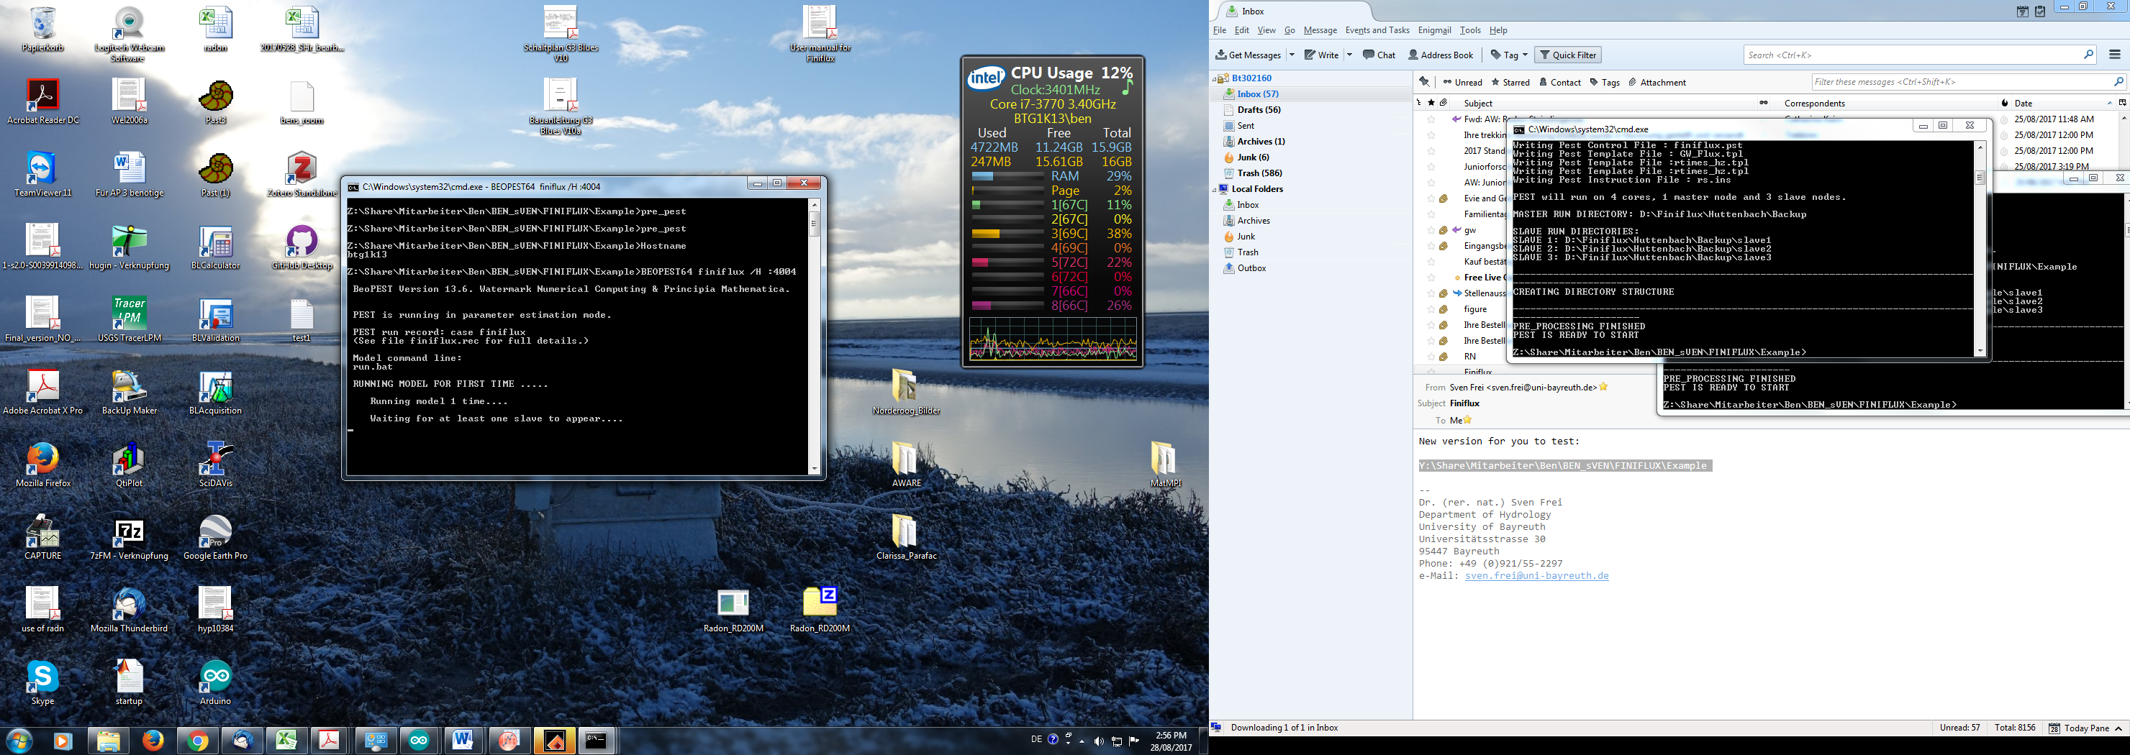

1. To start the salves open a new prompt in the slave1 folder using e.g. ‘Open Command Window Here’. Type ‘Beopest64 finiflux /h hostname:4004’ or ‘Beopest32 finiflux /h hostname:4004’. Hostname is the name of your computer, in my case, for example, btg1k13 so that for me to start a slave it looks like this: ‘Beopest64 finiflux /h btg1k13:4004’.

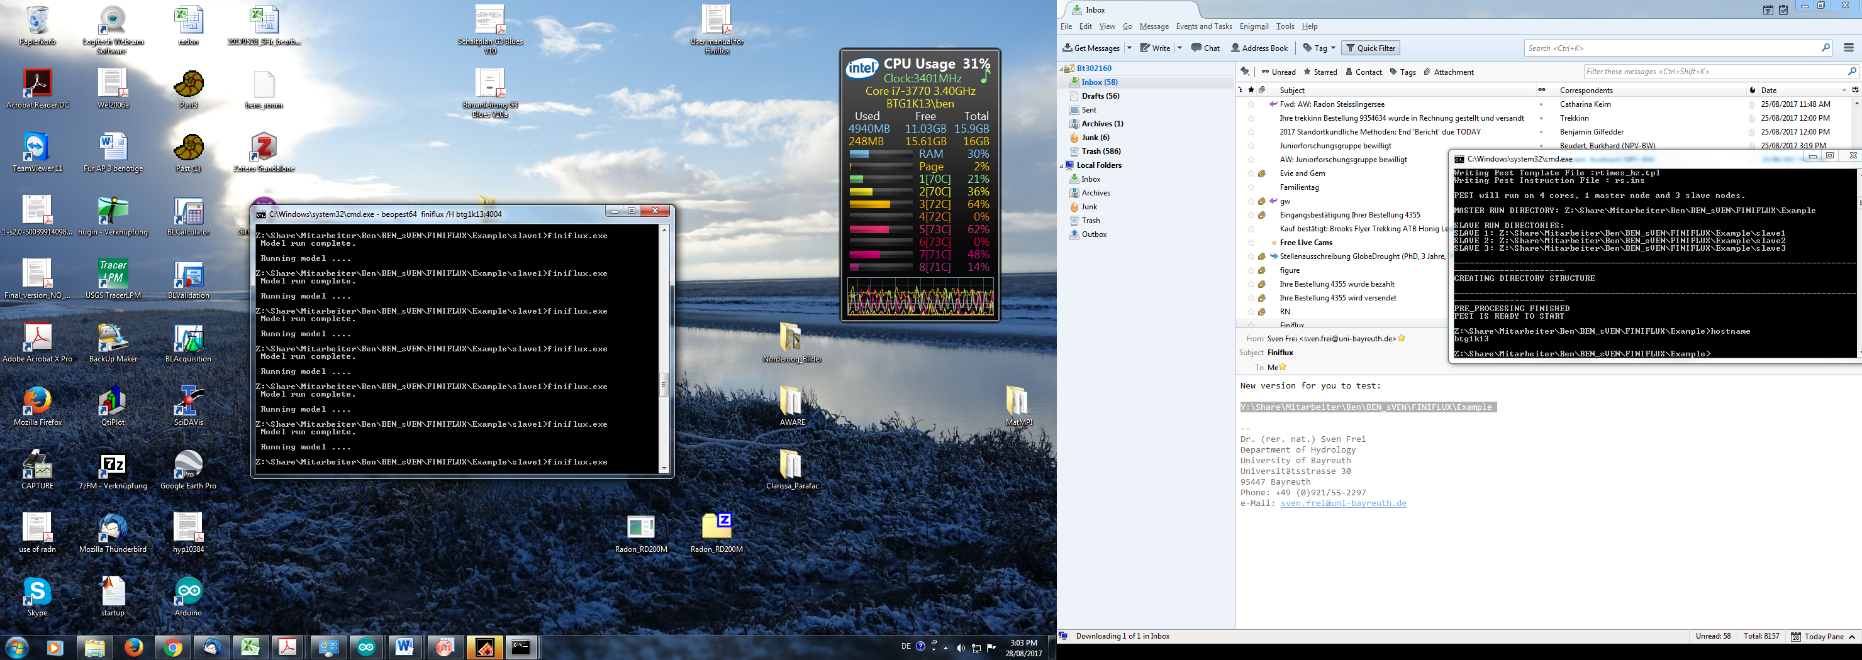

Do this for all of your slaves. You can also run the model over the internet. Here you need to replace hostname with the IP address of the master computer. For more info, check out the BeoPest manual included in the FINIFLUX folder.

1. We have written a small plotting program so that you see the progress BeoPEST is making with the optimisation. It is called pest_tracker.exe. You can run this by opening a command prompt in the main folder and typing pest_tracker. You can also put this file in your windows folder and then it will run from anywhere by simply typing the name. In this graph you see the measured Rn activities (blue dots) and the BeoPEST modelled activities broke line, which change with optimisation run, moving towards the measured values. Sometimes you need to click in the upper panel for it to update. In the lower panel you can see the development of the correlation coefficient between measured and modelled radon activities.



1. The optimisation will take some time (1-24h usually, but depends on the number of measurement points, CPUs, computer speed and number of slaves). When the optimisation is finished the Master will look like this:

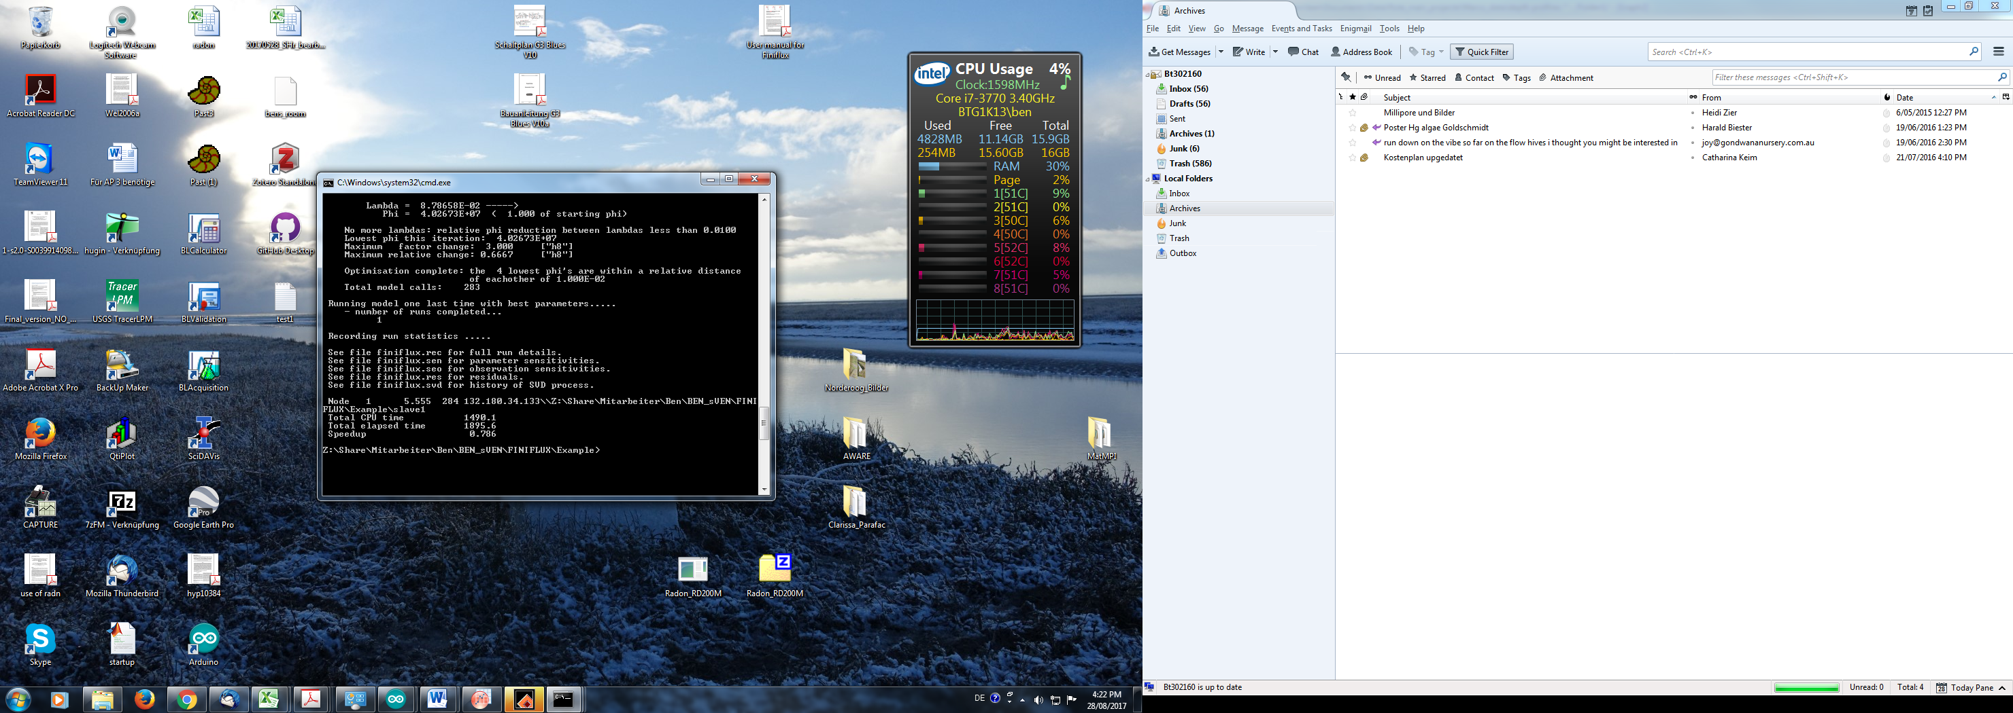

1. The first thing is to have a look at how well the data fits the measured values. We have written a small graphing program to do this - ‘Plot_Output.exe’. The actual values of measured and modelled data can be found in the **Finiflux.seo** file. This is a text document and can be opened in any text editor (we find Notepad++ convenient). This plot is not meant to be saved and published. It is simply too ugly. Please plot the data yourself nicely together with the groundwater fluxes and/or other variable of interest (e.g. hyporheic residence times).

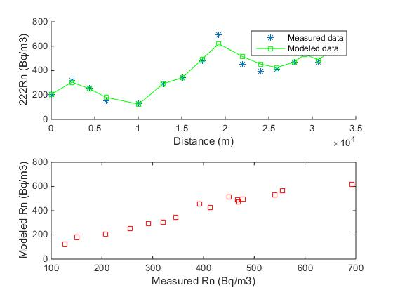

1. The calculated groundwater fluxes can be found in **slave 1** in the file **‘gw_inflow.dat’**. The groundwater flux units are in m3/m/s (sticking with SI units), but should probably be scaled to m3/m/d for better representation. This is of course for the user to decide. This is also a text file. You should probably also think about summing the groundwater fluxes over the whole river or at least the reaches so that you have groundwater flux in m3 d-1. Plotting the cumulative groundwater flux has also shown to be useful.
2. The goodness of fit (correlation coefficient as well as other indicators) calculated by PEST can be found in the **finiflux.rec** file. It is often located at the bottom of the file, but not always, and sometimes one needs to scroll around a bit to find it. It looks like this:

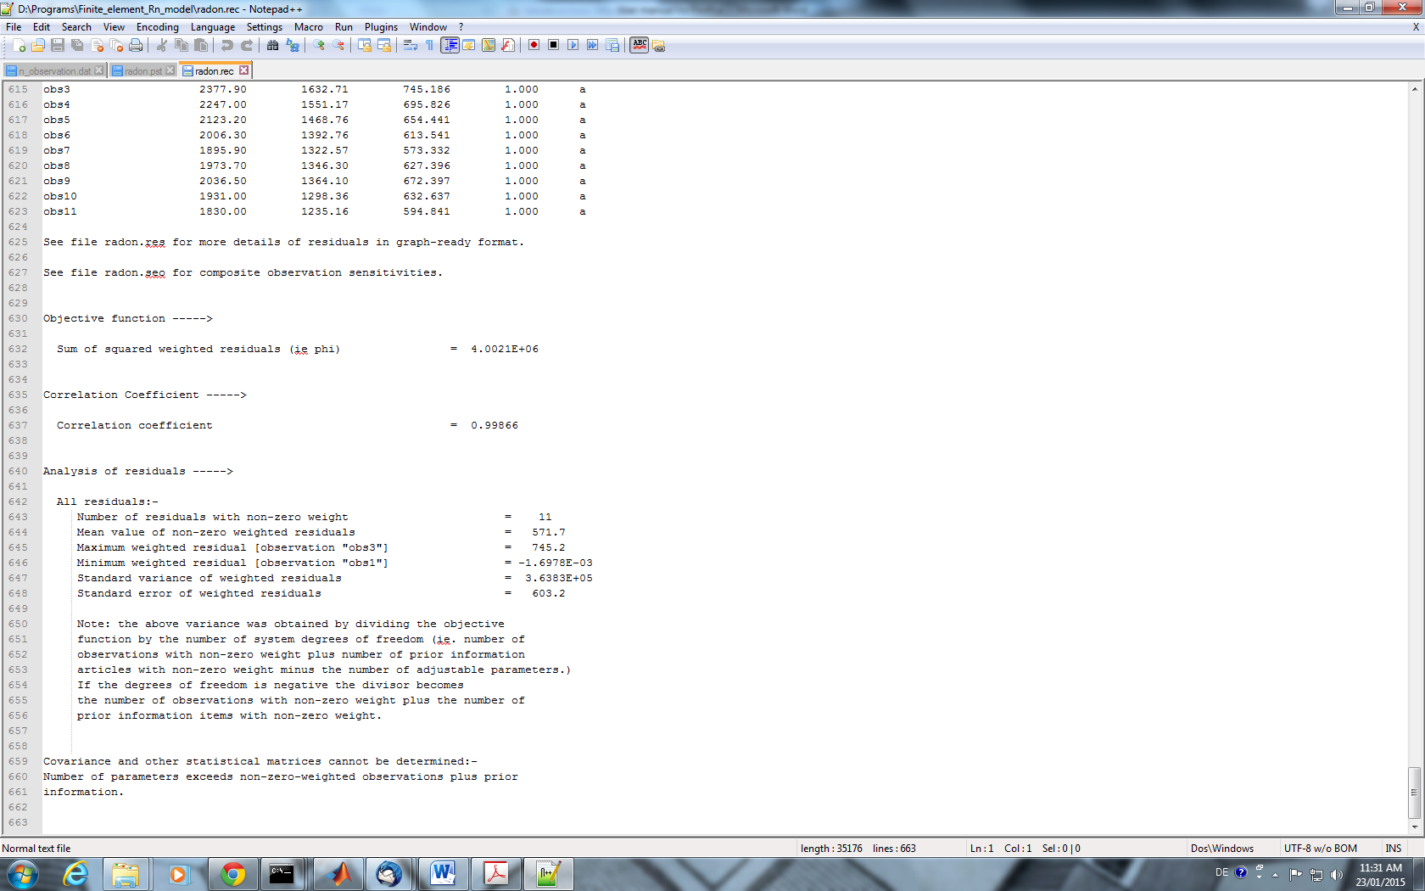

1. Optimised Hyporheic residence time can be found in slave1 in the file **‘rtimes_hz’**, with the units ‘seconds’.
2. The importance of hyporheic exchange for the goodness of fit can be found in the file **finiflux.sen** (text). Look at the last column (Sensitivity) of the last run (bottom of the file). The higher the number the more important the parameter is for determining the fit. Of course one can also run the model with and without hyporheic exchange (see file **hz_on_off**) and compare e.g. groundwater fluxes and goodness-of-fit to determine the importance of the hyporheic exchange.

Please let us know if you have any comments, requests or problems.

Ben Gilfedder and Sven Frei

**References**

Doherty, J.E., 2010. Methodologies and Software for PEST-Based Model Predictive Uncertainty Analysis. Watermark Numerical Computing, Brisbane, Australia.